**Design Pattern – Factory**

When getting a processor instance the getProcessorInstance function looks at the connection type and chooses the appropriate SQL processor class.

\src\main\java\org\jabref\logic\shared\DBMSProcessor.java

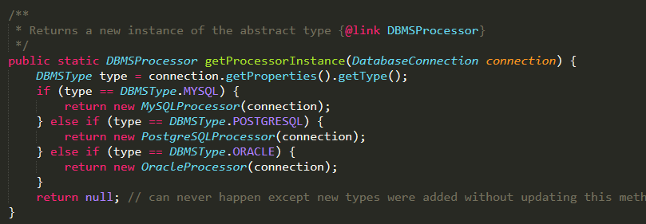

**Design Pattern – Template**

Many classes implement the methods (mainly the cleanup method) from the CleanupJob class, which then allows flexibility when running jobs from a list.

src\main\java\org\jabref\logic\cleanup\CleanupJob.java

src\main\java\org\jabref\logic\cleanup\EprintCleanup.java

src\main\java\org\jabref\logic\cleanup\FileLinksCleanup.java

and other classes that implement CleanupJob as well.

